SIMULATION EXPERIMENT – 3

Design of IIR Filters Using Impulse Invariance and Bilinear Transformation Methods Using MATLAB
Objectives of this Experiment:
1. To convert a suitable analog IIR prototype into a digital IIR filter using impulse invariance.
2. To convert the same prototype using the bilinear transformation method.
3. To investigate frequency warping and the need for prewarping in bilinear transformation.
4. To compare the digital filter coefficients and frequency responses obtained using both methods.
Program Code:

clear; clc; close all;

Fs = 5000;
T = 1/Fs;
fc = 1000;
Omega_c = 2 * pi * fc;

% Analog Filter Prototype: H(s) = Omega_c / (s + Omega_c)
b_a = [Omega_c];
a_a = [1, Omega_c];

% 1. Impulse Invariance Method
[b_imp, a_imp] = impinvar(b_a, a_a, Fs);

% 2. Bilinear Transformation Method (with Prewarping)
Omega_p = (2/T) * tan(Omega_c * T / 2); % Prewarped frequency
b_a_pre = [Omega_p];
a_a_pre = [1, Omega_p];
[b_blt, a_blt] = bilinear(b_a_pre, a_a_pre, Fs);

% ==========================================
% DISPLAY NUMERICAL OUTPUTS IN COMMAND WINDOW
% ==========================================
fprintf('=== EXPERIMENT 3: IMPULSE INVARIANCE vs BILINEAR TRANSFORMATION ===\n\n');

fprintf('Analog Cutoff Frequency (Omega_c): %.2f rad/s\n', Omega_c);
fprintf('Prewarped Analog Frequency (Omega_p): %.2f rad/s\n\n', Omega_p);

fprintf('--- IMPULSE INVARIANCE COEFFICIENTS ---\n');
fprintf('Digital Numerator (b_imp):\n');
disp(b_imp);
fprintf('Digital Denominator (a_imp):\n');
disp(a_imp);

fprintf('--- BILINEAR TRANSFORMATION COEFFICIENTS ---\n');
fprintf('Digital Numerator (b_blt):\n');
disp(b_blt);
fprintf('Digital Denominator (a_blt):\n');
disp(a_blt);

% Frequency Responses
[H_imp, f] = freqz(b_imp, a_imp, 1024, Fs);
[H_blt, ~] = freqz(b_blt, a_blt, 1024, Fs);

% Plotting
figure('Name', 'Impulse Invariance vs Bilinear Transformation');
subplot(2,1,1);
plot(f, abs(H_imp), 'b', 'LineWidth', 1.5); hold on;
plot(f, abs(H_blt), 'r--', 'LineWidth', 1.5); grid on;
legend('Impulse Invariance', 'Bilinear Transformation (Prewarped)');
title('Magnitude Response Comparison');
xlabel('Frequency (Hz)'); ylabel('Absolute Magnitude');

subplot(2,1,2);
plot(f, angle(H_imp)*180/pi, 'b', 'LineWidth', 1.5); hold on;
plot(f, angle(H_blt)*180/pi, 'r--', 'LineWidth', 1.5); grid on;
legend('Impulse Invariance', 'Bilinear Transformation');
title('Phase Response Comparison');
xlabel('Frequency (Hz)'); ylabel('Phase (degrees)');
Output:
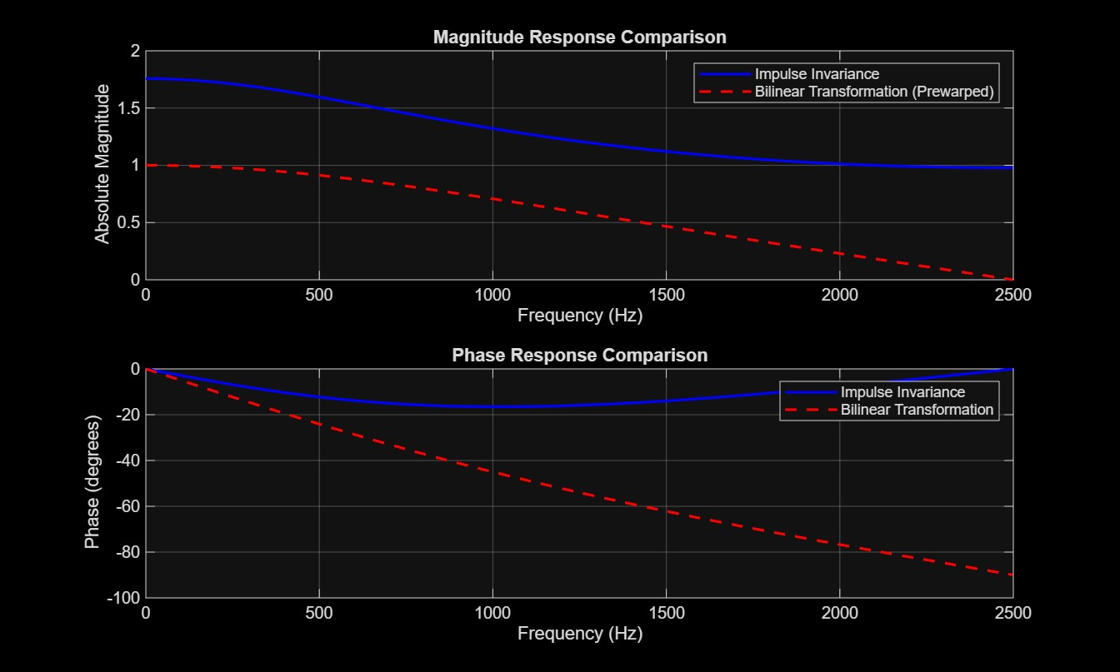
RESULT:
=== EXPERIMENT 3: IMPULSE INVARIANCE vs BILINEAR TRANSFORMATION ===

Analog Cutoff Frequency (Omega_c): 6283.19 rad/s
Prewarped Analog Frequency (Omega_p): 7265.43 rad/s

--- IMPULSE INVARIANCE COEFFICIENTS ---
Digital Numerator (b_imp):
1.2566

Digital Denominator (a_imp):
1.0000 -0.2846

--- BILINEAR TRANSFORMATION COEFFICIENTS ---
Digital Numerator (b_blt):
0.4208 0.4208

Digital Denominator (a_blt):
1.0000 -0.1584

>>

